APTA Conference Management System

# VU Collaborate

To get started right away, just tap any placeholder text (such as this) and start typing to replace it with your own.

Want to insert a picture from your files or add a shape, text box, or table? You got it! On the Insert tab of the ribbon, just tap the option you need.

Find even more easy-to-use tools on the Insert tab, such as to add a hyperlink or insert a comment.

# Student Info

* Name :
* Student ID :

# Background :

Apta works for social developments. They arrange conference for various topics. Tourism management is their main functions but they also arrange conference for science and technology.  
They want to increase the tourism business. If they use a conference management system for this purpose. Here attendee can easily submit their papers. The Apta can also record their attendee and  
organization details.

# Database Design

Here the database for managing the conferences and events of apta :   
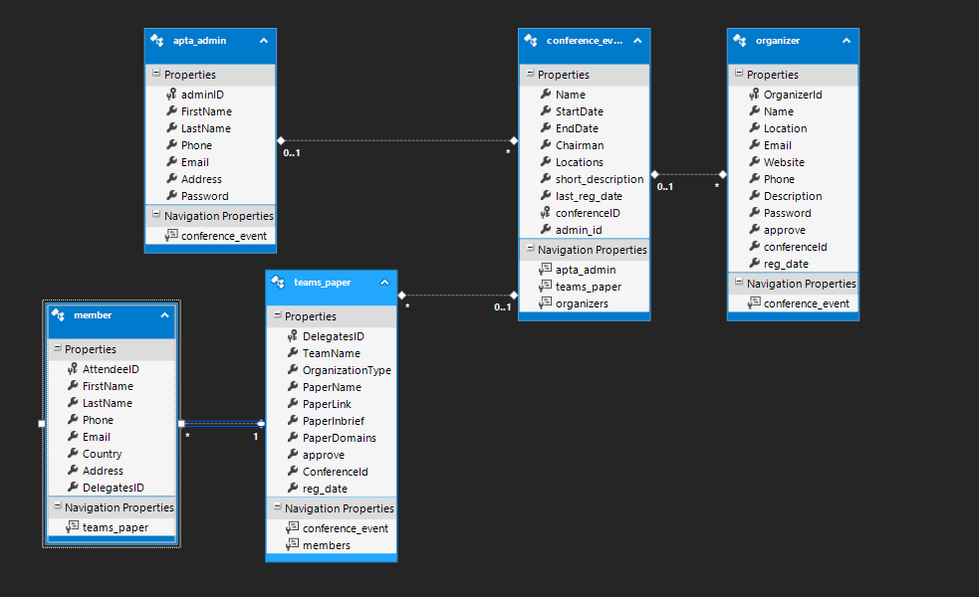

# User Manual

* **Apta Admin :**

**At first admin have to login :   
after successfully logged in admin can go to the admin panel**

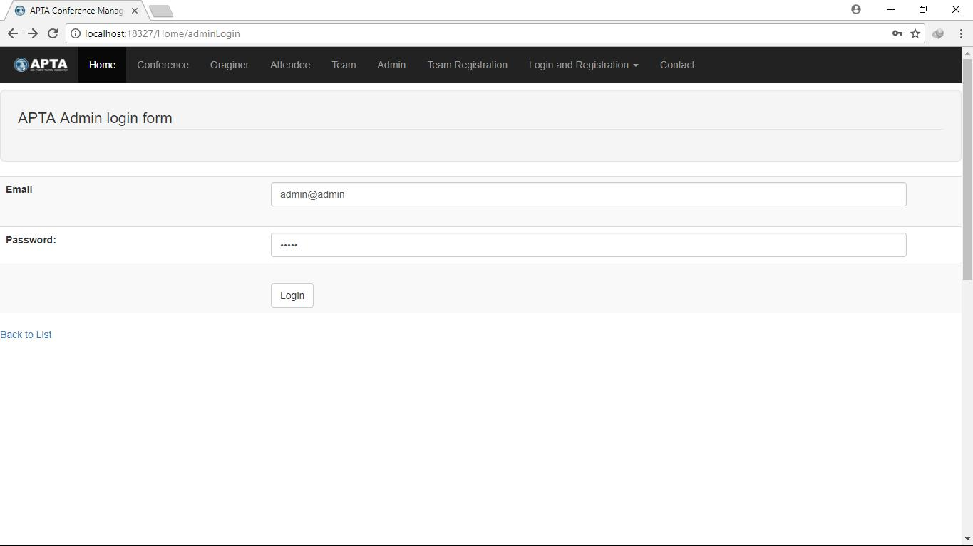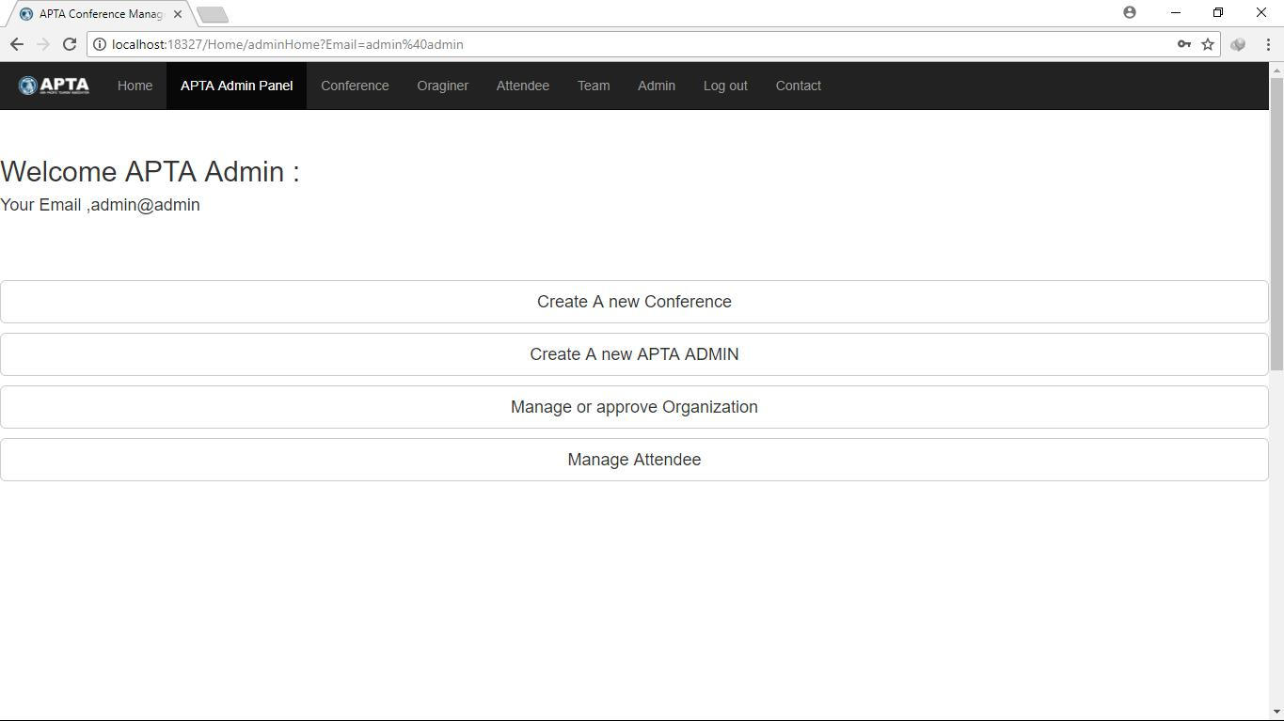

**Admin can publish and edit new events and conferences and see the details here.**

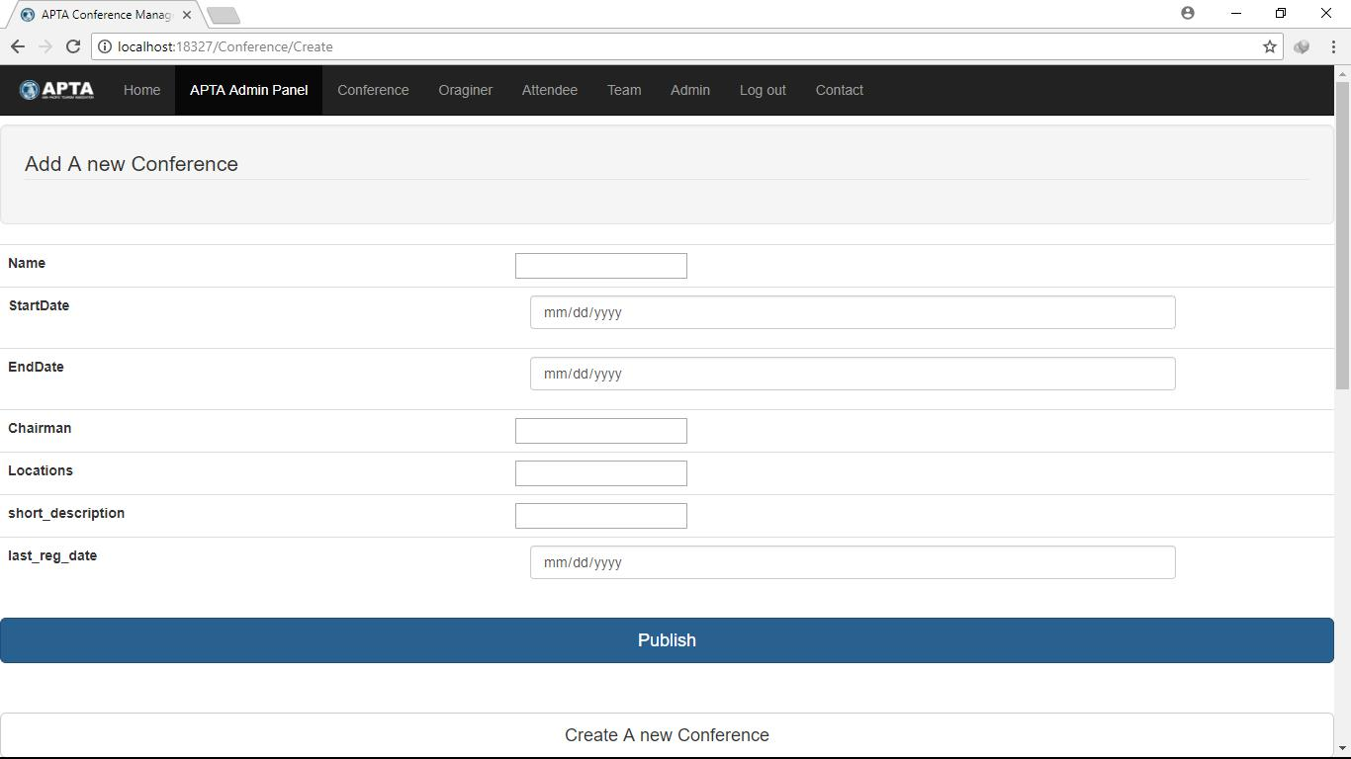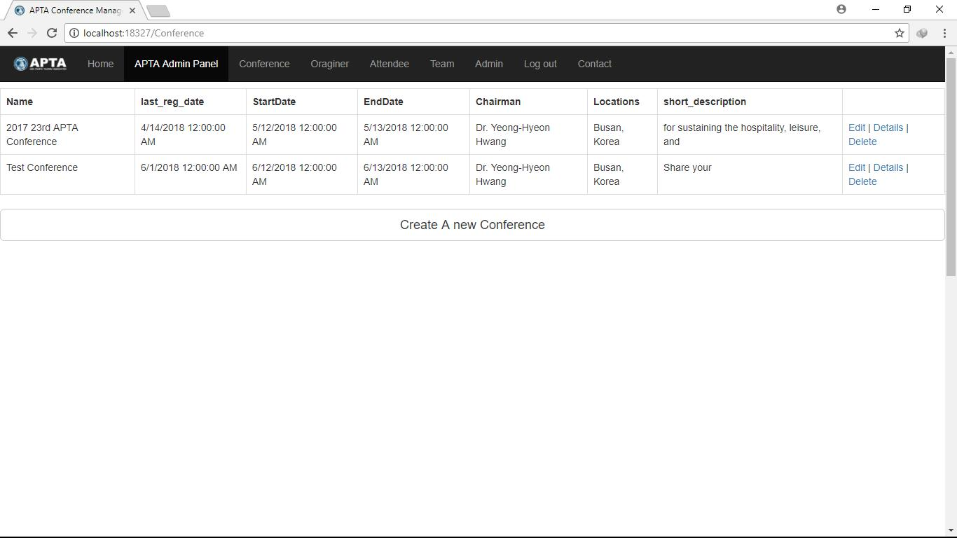

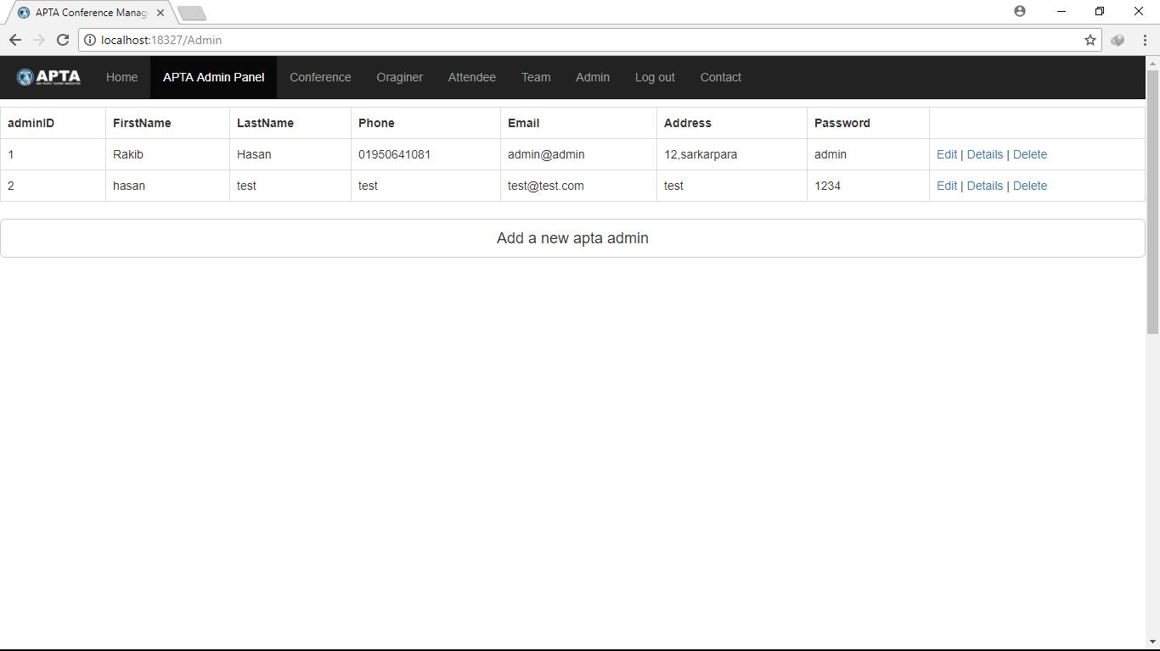**Admin Can Add and See APTA ADMIN 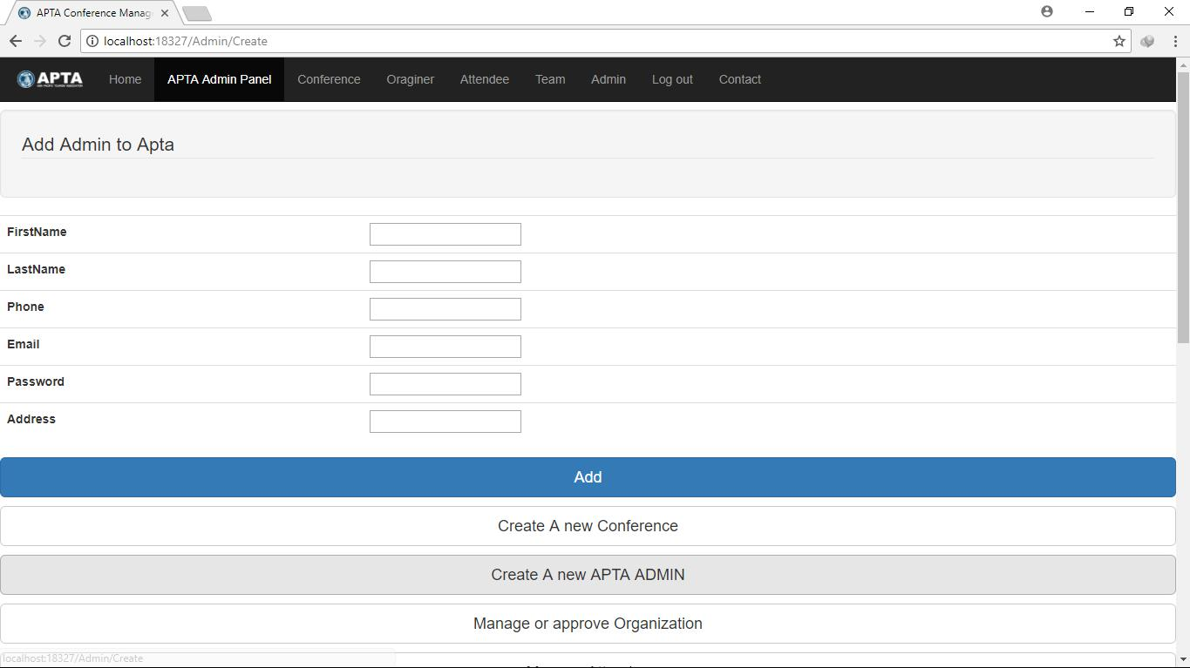 From the Navbar admin can also manage organization an attendee.**

* **Attendee**

**For register a conference or event attendee have to create their team first.**

**Then add them to the team. The pictorial view is here :   
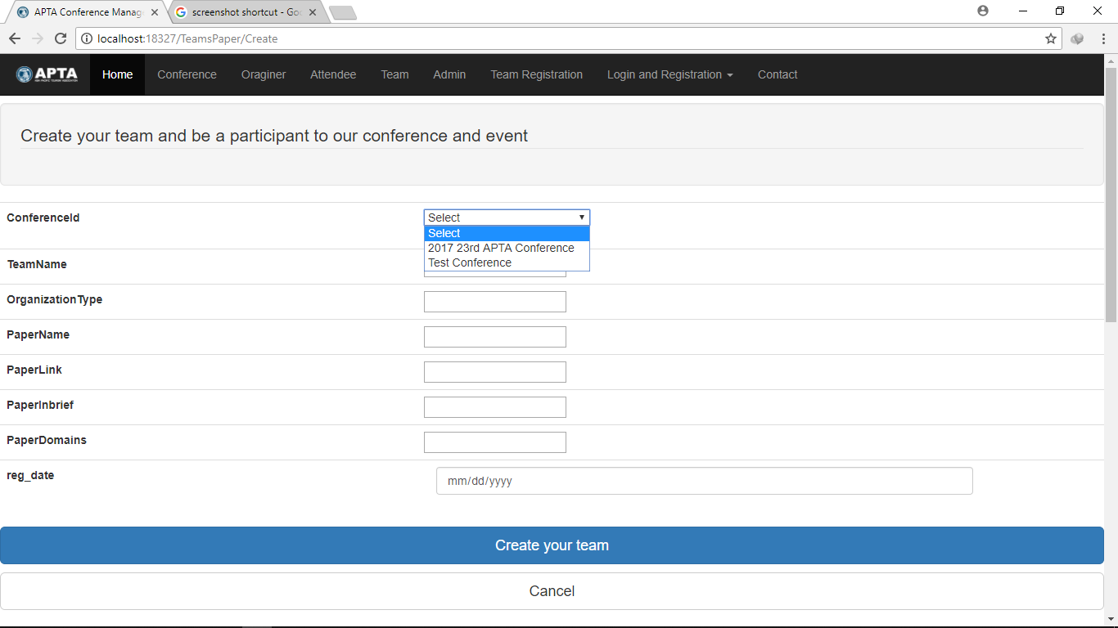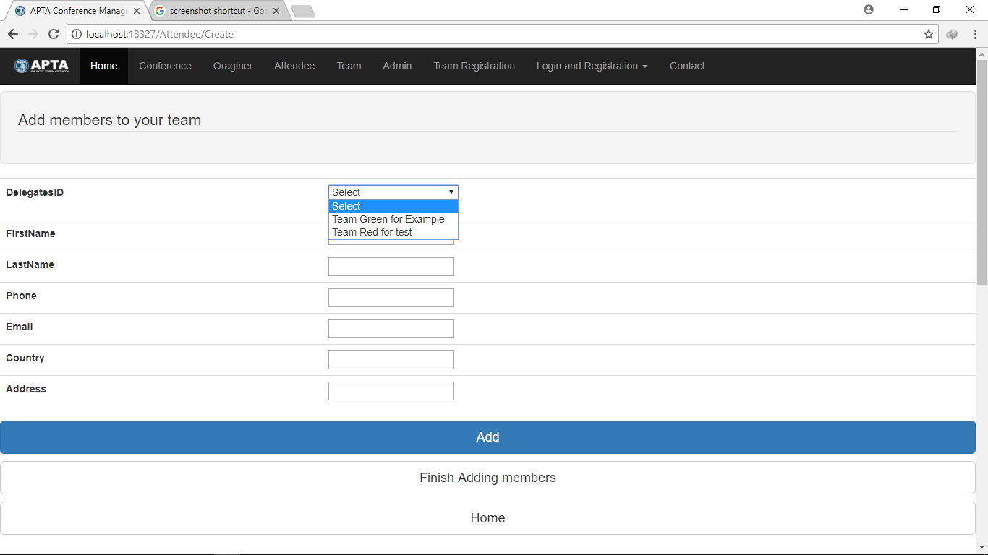**

* **Organizer :**   
  They have to register for a new event/conference. Then they can login later to manage it.   
  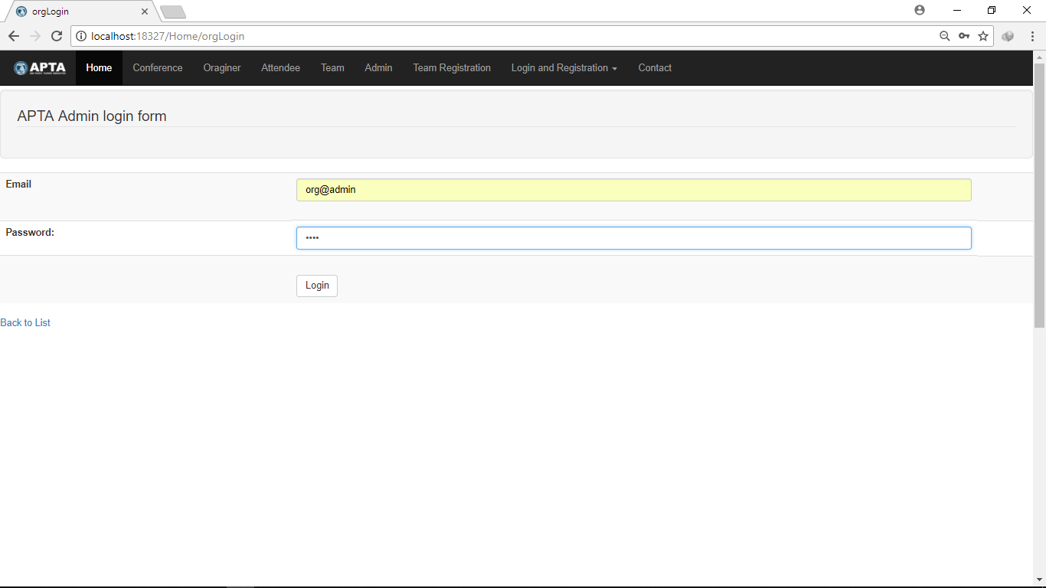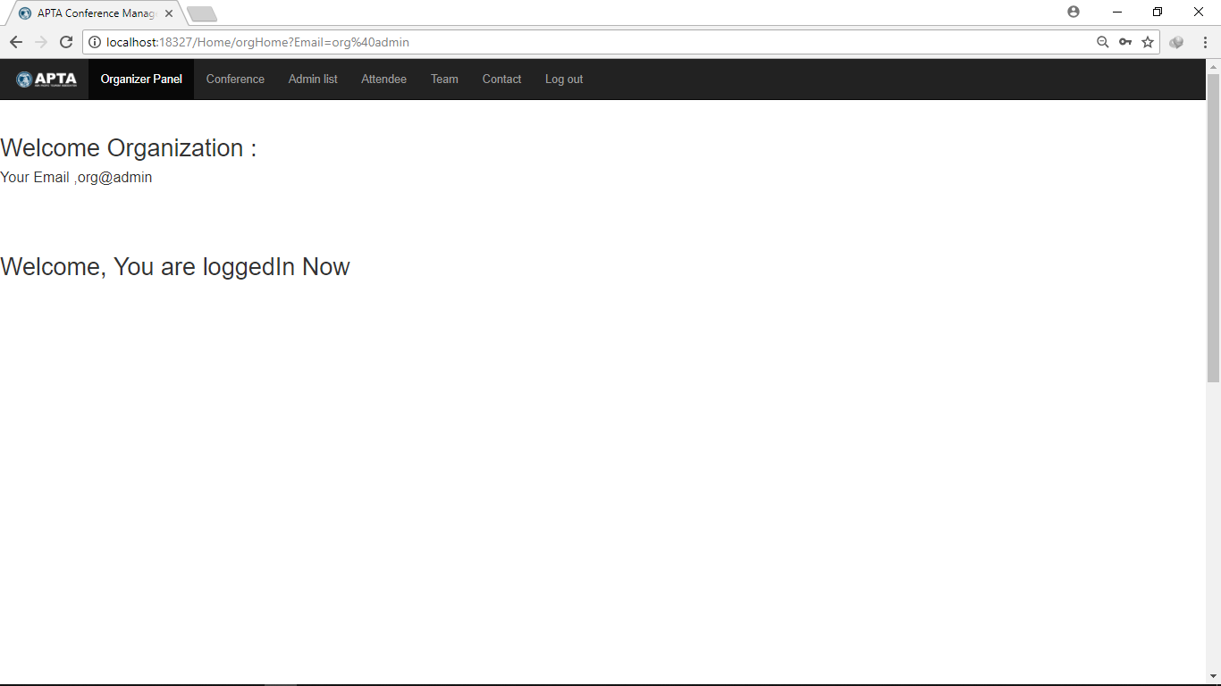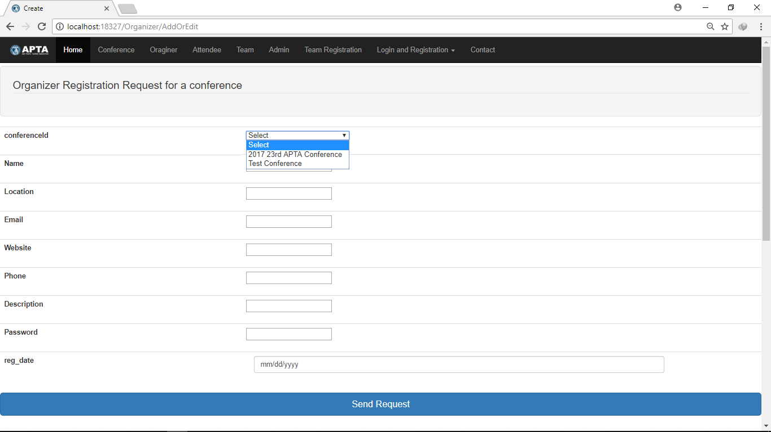

# Test Instruction : 1. Wrong email and password :

2. Empty field/Invalid field:

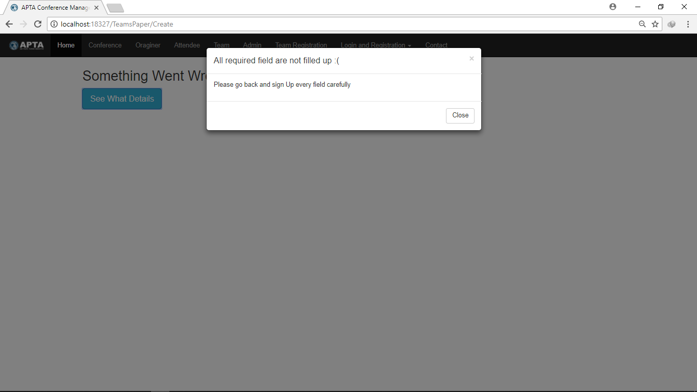

**--------------------------------- End --------------------------------**